Soundzania
is a place that you can go…

Soundzania is a children's album designed to inspire young minds to learn more and do more with instruments. In the interest of this mission, we visit local schools and churches to introduce the instruments and sing songs to the children.

Join Ben Joe and Mandy Lynn on their Soundzania Radio show as they explore some of the sounds, songs and instruments of Soundzania, a magical place where instruments come to life and play together. They are happy to share their music with you and they encourage everyone to create music wherever they may go.

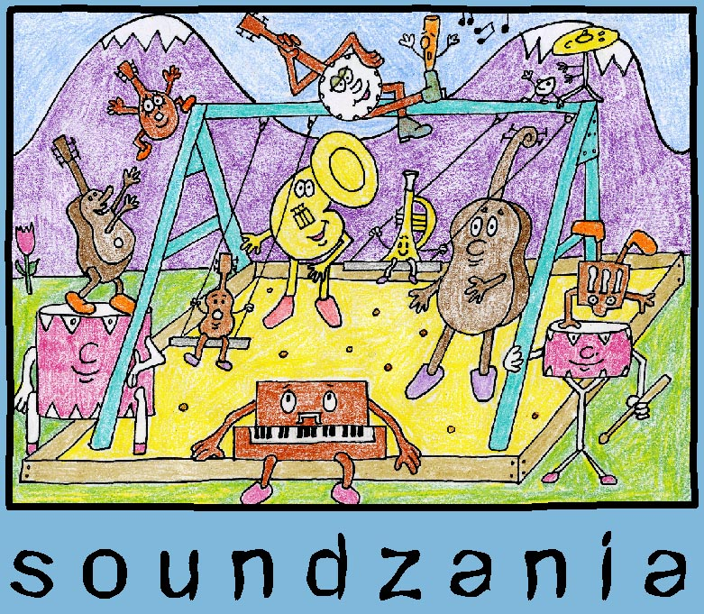

Some of what people are saying about Soundzania
The following comments have been posted by visitors to our website, you can see all of them at www.soundzania.com :

“Let's hope kids all over the country will jam to your fun songs!” – Allie

“We are having so much fun listening to our Soundzania CD!” – Stephanie


“Madeline started tapping her feet to the first song right away and we all loved singing the Daddy song.” – Tracy

“Wow, what a great gift! Very fun indeed… Addie started dancing as soon as I popped it in the stereo.” - Gian

“Sammy was SO inspired he drew pictures the whole time we listened. Sammy told me the music inspired him. Soundzania is a masterpiece.” - Gini

“My kids loved the CD… This CD may replace the Wiggles as most requested by the kids during car trips.” - Mike

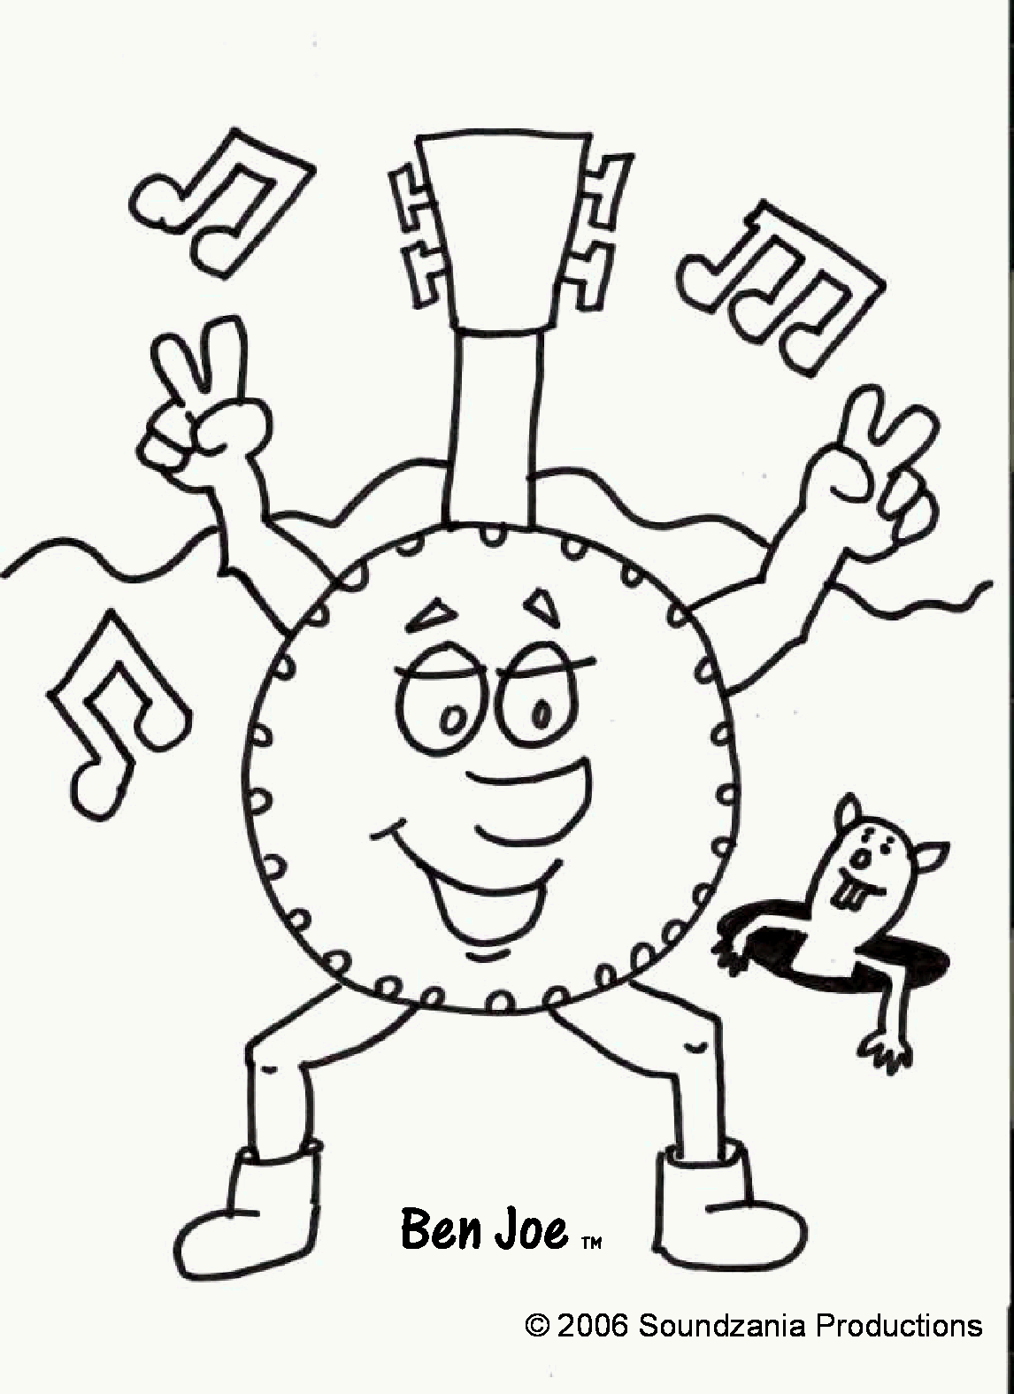
The Making of Soundzania
Motivation came easily to the three dads that created the musical world of Soundzania. Two years after band-mates Scott Flory, Ken Hougasian, and Lee Parker gave up the late nights and smoky-club lifestyle of a rock band, all three began enjoying the late nights and smelly-diaper lifestyle of fatherhood.

Independently, Scott, Ken and Lee each lovingly created music to make their kids smile (or, in some cases, sleep). After rave reviews from their own children, they set out to create Soundzania. With help from musician friends and engineers, each song on the album was transformed from a private lazy-morning guitar sing-along or quiet bedside lullaby into a musical world filled with banjos, kazoos, mandolins, and even a sousaphone.

Every song has been tested for silliness, smiles, and nap-worthiness by the band's collective children: Julia, Alex, Max, Sam, Claire, Hannah, Nora, and Owen.

The band hopes this album will bring giggles and snoozes to your family as well.

